Remediation REST API Design

Introduction
This document details the API request flows for the Malware Detection and Remediation System. The API is implemented using Node.js and Express.js. The purpose of the API is to serve as the bridge between the malware detection engine, the relational database, and the user interface. Its primary role is to expose well-defined endpoints for initiating scans, retrieving scan results, querying malware information, and obtaining remediation guidance for end users.

Architectural Overview
The API uses a layered architecture to improve the maintainability, scalability, and clarity of the system. The architecture is divided into five main layers:
- Routes: Define HTTP endpoints and map requests to required controller functions.
- Controllers: Handle HTTP-specific logic, like extracting request parameters and return responses.
- Services: Contain the core business logic, such as initiating scans or aggregating detection results.
- Repositories: Encapsulate all the database access and provide an abstraction over repeated operations.
- Models: Represent the database entities using Sequelize and define relationships between tables.
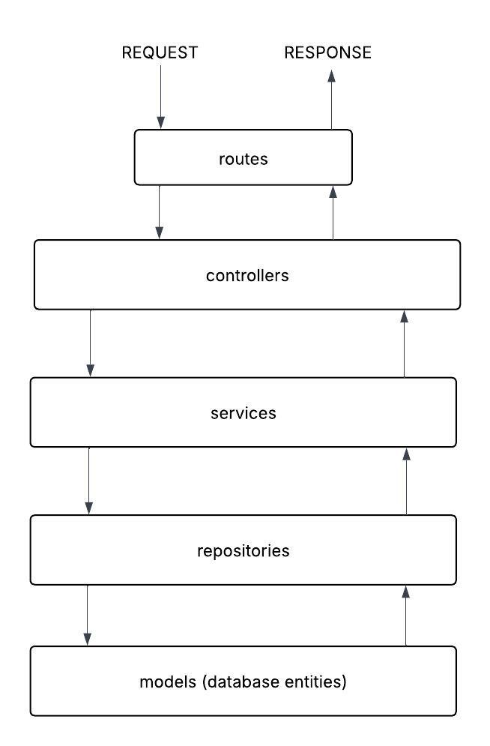

The diagram above illustrates how an incoming HTTP request flows from the routing layer down through to the model layers, before the response to the required resource is returned to the client. This structure ensures that each layer has a single, well-defined responsibility in the API build.

Technology Stack
The API is implemented using the Node.js and Express.js framework. Node.js provides an event-driven structure and the framework reduces the integration complexity by enforcing clear boundaries between different layers and their responsibilities. I chose Node.js and Express.js over the Java and Springboot because it offers a more flexible framework for defining routes.

Conclusion
The Node.js and Express.js REST API provides a modular foundation for the Malware Detection and Remediation System. By following established REST design principles and employing a layered architecture, the API helps ensure maintainability, scalability, and clarity of design. It effectively supports the core system requirements of scan management, malware information retrieval, and remediation guidance, and forms a key component of the overall system architecture of the program.

